1. Create EC2 Instance and allow all traffic and install docker and enable the docker server.
2. Docker by default run in EC2 root user. If we want to run in ec2-user than we need to follow the below steps.

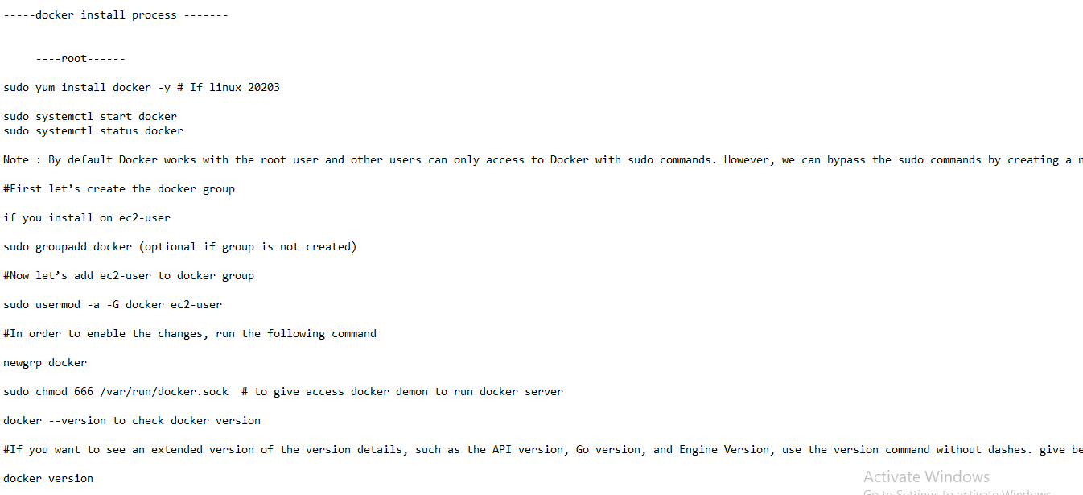

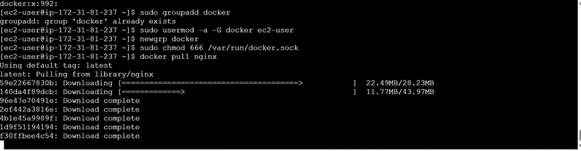

1. Docker Run instructions.

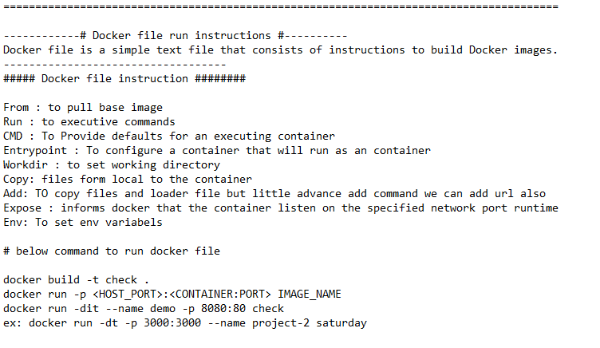

1. Dockerfile Practice Test.

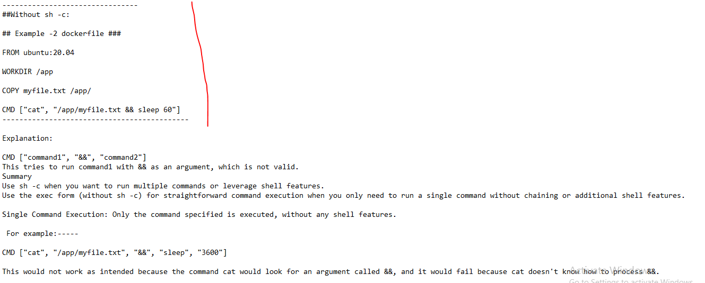

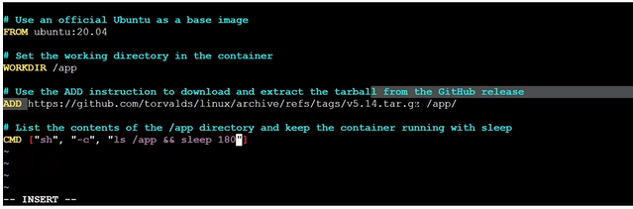

**ADD** We will use for from different resourse. Using this we can download git code from different resourse to **app** folder

1. If we want to run a container with some name.

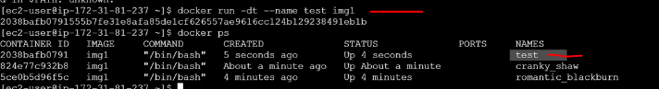

1. Another example.

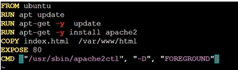

It is suggesting apache should run in foreground. Please build and run.

